Ex:No: 12
Simple Programming using REPEAT, WHILE

Aim:
To learn how to use various MySQL loop statements including while, repeat to run a block of code repeatedly based on a condition.
Program-1:
Write a function that uses WHILE statement to build a string repeatedly until the value of
the variable becomes x greater than 5. Then, we display the final string using a SELECT statement.
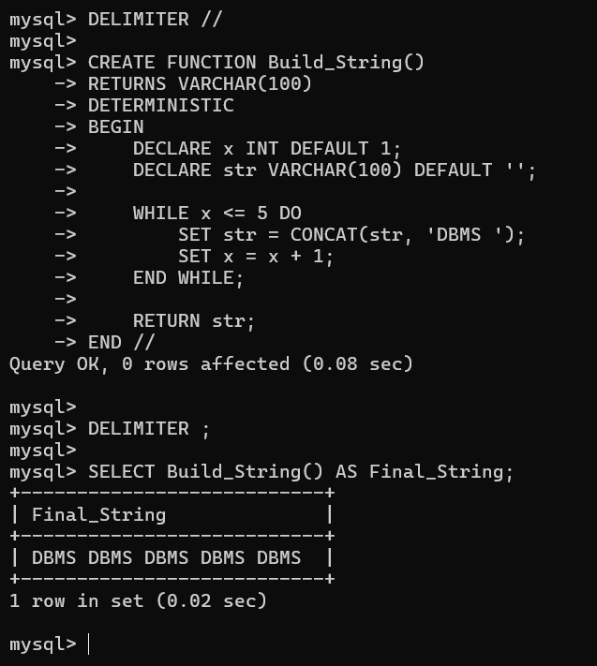

Program-2:
Write a function that uses REPEAT statement which would repeat the loop until income is greater than or equal to 4000, at which point the REPEAT loop would be terminated.
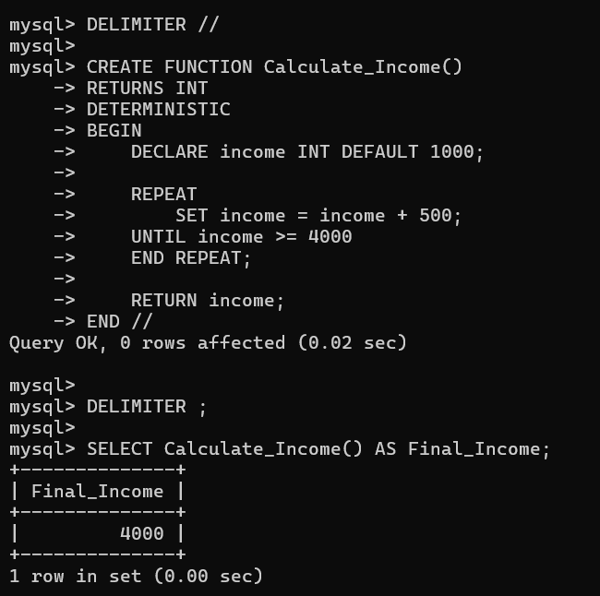

RESULT: Thus the Simple programming exercise using (REPEAT, WHILE )executed successfully.

